# **TECHNICAL SOL. PROPOSAL**

for

AnyCompany Corporation

Group- **Group9**

Shivam Verma **(414384)**

Khushi **(438909)**

**Experian IT Solutions**

Experian IT Solutions is interested in proposing a collaboration agreement with AnyCompany Corporation, with the aim of delivering several benefits that include secure storage of important data and a seamless experience with their IT system. Experian IT Solutions is dedicated to installing a dependable network and guaranteeing that any system malfunctions will be promptly addressed over the next five years. The company is enthusiastic about the opportunity to work with AnyCompany Corporation and is eager to explore this proposal in more detail.

The proposal represents a sincere effort by Experian IT Solutions to establish a meaningful partnership with AnyCompany Corporation, and the company is committed to working collaboratively to achieve mutual goals and objectives.

# **Table of Content**

1. Goals and Objectives 4
2. Computer Systems for each Employee 5

* Detailed specifications of all the computer systems 6
* Other Hardware Devices 9

1. Budget Summary 11
2. ISP Selection 12
3. Internal Services Required 13
4. Network Planning 14
5. Physical Layout 15
6. Work Schedule 16
7. Addressing Scheme 17
8. Logical Layout 18
9. Security & Login Details 19
10. Contact Us 20

# **Goals and Objectives**

The primary goal of this project is to enhance the existing IT infrastructure to accommodate the company's expansion plans and establish a formidable presence in a new market while also preparing for future demands. This project seeks to achieve a multi-faceted objective, which includes creating a secure and reliable IT system that is not only cost-effective but also meets the needs of all employees. By doing so, we aim to ensure that employees enjoy a seamless work experience, which will enhance their productivity and contribute to the overall success of the company.

# **Computer Systems for each Employee**

Each employee's computer system has been chosen based on their specific needs to ensure that they can complete their tasks efficiently. The Administrative Manager has been provided with a standard desktop PC with regular specifications, which will be connected to the internet via an ethernet cable. On the other hand, the Film Editor requires a high-end desktop PC with specific parts selected to handle the editing of large, high-resolution videos with ease. The PC also features a 4K monitor for better visualization. The Film Crew, on the other hand, has been provided with laptops that have basic configurations, ideal for their regular tasks. However, they require larger storage capacity to store large film files, which is why their laptops are equipped with 2TB hard drives, more than sufficient for multiple large files.

Detailed specifications of all the computer systems:

|  |  |
| --- | --- |
| Job Role: Administrative Manager | |
| Location: Administrative Manager’s Office | |
| Component | Recommendation |
| Model | Dell I5000MC |
| Processor:  (Manufacturer, Model, Speed) | 2.6GHz hexa-core Intel Core i5-11400 |
| Memory:  (Type, Amount) | 16GB of DDR4 U-DIMM RAM |
| Hard Drive:  (Type, Capacity) | 512GB M.2 NVMe PCIe 3.0 solid state drive (SSD) |
| CD-ROM/DVD:  (Read, Read/Write, Speed) | N/A |
| USB Ports:  (Number, Location) | 2x USB 2.0 Type-A; 1x USB 3.2 Gen 1 Type-C ; 1x USB 3.2 Gen 1 Type-A, 2x USB 2.0 Type-A ; 2x USB 3.2 Gen 1 Type-A |
| Video Card:  (Manufacturer, Model, Video RAM) | Radon Graphics 730 |
| Sound Card:  (Manufacturer, Model) | Intel S560 Chipset |
| Modem:  (Internal/External, Speed, Standard) | N/A |
| Network Card(s):  (Ethernet: speed, Wireless, Standard) | Wi-Fi (802.11ax) and 10/100/1000 gigabit ethernet, Dual band Bluetooth 5.2 |
| Operating System:  (Manufacturer, Version, Compatibility) | Windows 10 Ultimate pro |
| Monitor:  (Size, Resolution, Refresh Rate) | Acer 23.8" FHD 75Hz 1ms GTG VA LED Monitor  1920 x 1080 |
| Printer:  (Manufacturer, Model, Type, Speed) | Canon Color LaserJet Pro M2550 |
| Speakers:  (Manufacturer, Model, Type) | Boat z150 Multimedia Speakers |
| Internet Connection:  (USB, Ethernet, Wireless) | Wi-fi, Ethernet |

|  |  |
| --- | --- |
| Job Role: **Film and Graphics Editor** | |
| Location: Film Editor’s Office | |
| Component | Recommendation |
| Model | HP Omen 30L |
| Processor:  (Manufacturer, Model, Speed) | 2.5GHz Intel Core i7-11700F |
| Memory:  (Type, Amount) | 16GB (2 x 8GB) of HyperX DDR4-3200 XMP SDRAM |
| Hard Drive:  (Type, Capacity) | 1TB of WD PCIe NVMe M.2 solid state drive (SSD) |
| CD-ROM/DVD:  (Read, Read/Write, Speed) | N/A |
| USB Ports:  (Number, Location) | 4- USB Type-A  2- USB Type-C  2- USB Type-A 2.0 |
| Video Card:  (Manufacturer, Model, Video RAM) | **NVIDIA GeForce RTX 3070 graphics card with 8GB GDDR6** |
| Sound Card:  (Manufacturer, Model) | **6.1 surround sound** |
| Modem:  (Internal/External, Speed, Standard) | N/A |
| Network Card(s):  (Ethernet: speed, Wireless, Standard) | Intel Wi-Fi 6 AX 201 (2x2), Bluetooth 5,  10/100/1000 Base-T Network |
| Operating System:  (Manufacturer, Version, Compatibility) | Windows 10 Ultimate |
| Monitor:  (Size, Resolution, Refresh Rate) | LG 31.5" 4K UHD 60Hz 4ms |
| Printer:  (Manufacturer, Model, Type, Speed) | N/A |
| Speakers:  (Manufacturer, Model, Type) | Samsung SWA-9100S/ZC |
| Internet Connection:  (USB, Ethernet, Wireless) | Ethernet, Wi-fi |

|  |  |
| --- | --- |
| Job Role: Film Crew | |
| Location: Office area for mobile workers | |
| Component | Recommendation |
| Model | HP 15-dy2048ca |
| Processor:  (Manufacturer, Model, Speed) | 4.2GHz Intel Core i5-1135G7 quad-core |
| Memory:  (Type, Amount) | 8GB of DDR4 RAM |
| Hard Drive:  (Type, Capacity) | 2TB NVMe PCIe M.2 SSD |
| CD-ROM/DVD:  (Read, Read/Write, Speed) | N/A |
| USB Ports:  (Number, Location) | 1- Type-C  2- Type-A |
| Video Card:  (Manufacturer, Model, Video RAM) | **Intel Arc A770 Limited Edition** |
| Sound Card:  (Manufacturer, Model) | Intel B560 Chipset |
| Modem:  (Internal/External, Speed, Standard) | N/A |
| Network Card(s):  (Ethernet: speed, Wireless, Standard) | Intel Wi-Fi CERTIFIED 6 AX201  Bluetooth 5 combo |
| Operating System:  (Manufacturer, Version, Compatibility) | Windows 11 Pro |
| Monitor:  (Size, Resolution, Refresh Rate) | 15.6-inch FHD 1920 x 1080 |
| Printer:  (Manufacturer, Model, Type, Speed) | N/A |
| Speakers:  (Manufacturer, Model, Type) | 2 Dolby Audio |
| Internet Connection:  (USB, Ethernet, Wireless) | Wi-fi |

# **Other Hardware Devices**

|  |  |
| --- | --- |
| **Device** | **Description** |
| Printer | Shared: EcoTank Pro ET-5850 ‘Supertank’ Printer  Admin’s Private Printer: HP Color LaserJet Pro M255dw |
| Switch | Cisco Systems CISCO SYSTEMS 24 Port Ethernet Switch |
| Server | ThinkSystem SR655 7302P |
| Firewall Router | Cisco ASA5506-K9= Network Security Firewall Appliance |
| Wireless Router | Cisco System RV180 VPN Router |

The Eco Tank Pro ET-5850 'Super Tank' printer has been selected as the shared printer for all employees. This printer is equipped with Precision Core Heat-Free Technology, enabling it to print up to 25 ISO ppm in both black and color. It has a fast first page out time and does not require any warm-up time. Additionally, it comes with a built-in scanner, copier, fax, and Ethernet capabilities.

For the administrative manager's private use, the HP Colour LaserJet Pro M255dw printer has been selected. It can print up to 22ppm in both black and color and fits within the allocated budget.

To ensure network security, the Cisco ASA5506-K9 Network Security Firewall Appliance will be used. It functions as both a security firewall and router. The Cisco System RV180 VPN Router will provide wireless connectivity to the film crew's computer systems, and temporary workers will also be able to connect to the internet through this router.

A powerful server has been chosen for the company to provide email and FTP services, enabling employees to transfer files to each other's computers. The server's detailed specifications will be provided below.

|  |  |
| --- | --- |
| Job Role: Server | |
| Location: XXX XXXXX XXXX | |
| Component | Recommendation |
| Model | ThinkSystem SR655 7302P |
| Processor:  (Manufacturer, Model, Speed) | AMD EPYC™ 7742 24 cores up to 3.2GHz  192MB cache |
| Memory:  (Type, Amount) | 128GB DDR4 memory with speed up to 2933MHz |
| Hard Drive:  (Type, Capacity) | 12TB NVMe PCIe M.2 SSD |
| CD-ROM/DVD:  (Read, Read/Write, Speed) | N/A |
| USB Ports:  (Number, Location) | 4x USB 3.1 G1 ports |
| Video Card:  (Manufacturer, Model, Video RAM) | NVIDIA RTX A2000 12GB |
| Sound Card:  (Manufacturer, Model) | N/A |
| Modem:  (Internal/External, Speed, Standard) | N/A |
| Network Card(s):  (Ethernet: speed, Wireless, Standard) | Ethernet 10Gb DP 530T |
| Operating System:  (Manufacturer, Version, Compatibility) | **Windows Server OS** |
| Monitor:  (Size, Resolution, Refresh Rate) | N/A |
| Printer:  (Manufacturer, Model, Type, Speed) | N/A |
| Speakers:  (Manufacturer, Model, Type) | N/A |
| Internet Connection:  (USB, Ethernet, Wireless) | Ethernet |

# **Budget Summary**

Our company has carefully selected components that fulfil our needs while staying within a limited budget. The setup we have chosen is also future proof, meaning that there will be no need for upgrades for at least six to seven years.

The estimated pricing for this setup includes the cost of windows upgrade, monitors, speakers, storage upgrades, etc. Please note that these prices are subject to change based on market prices and any changes to the device specifications made by the company. It is important to note that the prices listed do not include taxes or GST.

|  |  |
| --- | --- |
| **Devices** | **Price** |
| ASUS S500MC | $1,149 |
| HP Omen 30L | $3,316 |
| 6 x HP 15-dy2048ca | $1,056 x 6= $6,336 |
| ThinkSystem SR655 7302P | $9,899 |
| HP Color LaserJet Pro M255dw | $449 |
| EcoTank Pro ET-5850 ‘Supertank’ Printer | $1,299 |
| Cisco System RV180 VPN Router | $250 |
| Cisco Systems CISCO SYSTEMS 24 Port Ethernet Switch | $104 |
| Cisco ASA5506-K9= Network Security Firewall Appliance | $1,320 |
|  |  |
| **Other Costs** |  |
| Estimated Labor cost | $3,300 |
| Cable costs | $2,900 |
| Other costs (such as Anti-viruses, studio software etc.) | $499 |
|  |  |
| **Total** | $30.821 |

# **ISP Selection**

When it comes to selecting an internet service provider (ISP) for webmail’s and DNS, there are two prominent options that offer reasonable prices, 24/7 customer support, and good customer experiences. Between these two choices, TELUS stands out with its 99.9% uptime guarantee and above 900Mbps speed, all at an attractive price point. Therefore, our company suggests that you consider choosing TELUS as your ISP over any other competitors in the market.

|  |  |  |
| --- | --- | --- |
|  | **TELUS** | **SHAW** |
| **Plan** | Fibre Internet 1G | Business Internet gig |
| **Download Speed** | Up to 940 Mbps | Up to 1 Gbps |
| **Upload Speed** | Up to 940 Mbps | Up to 150Mbps |
| **Monthly Data** | Unlimited | Unlimited |
| **Dynamic IP’s** | 2 | 1 |
| **Technical Support** | 24/7 | 24/7 |
| **Uptime Guarantee** | 99.99% | N/A |
| **E-mail accounts** | 10 | 10 |
| **Cost** | $190/month | $220/month |

# **Internal Services Required**

AnyCompany Corporation will provide internal services via their company server. These services include:

1. **Email (SMTP**): This service utilizes the Simple Mail Transfer Protocol to transport electronic mail between different hosts.
2. **FTP**: The File Transfer Protocol enables users to send and receive files, making it easier for employees to share large files.
3. **DNS**: The Domain Name System translates different domain names into IP addresses, allowing users to use domain names instead of IP addresses for websites, which are easier to remember.
4. **DHCP**: The Dynamic Host Configuration Protocol assigns an IP address, subnet mask, gateway address, and DNS server address to hosts.

# **Network Planning Form**

|  |  |
| --- | --- |
| Are wired connections required? -Yes | Number: 7 |
| Are wireless connections required? -Yes | Number: Min 6 |
| Wireless standard | Choice of a/b/g/n/ac |
| Firewall required? | Yes |
| ISP connectivity required? | Yes |
| Type of ISP connectivity | Fibre-optic cable |
| Internal or external modem required? | Yes, both internal Optical Network Modem and external broadband modems are required. |
| Cables required? | Yes  Cat 6 ethernet cables and fibre-optic cables will be used. |
| Battery backup required? | No |

# **Physical Layout**

# **Work Schedule**

The majority of the project work will be completed outside of regular business hours in order to minimize disruptions. Specifically, the work will likely be conducted during night-time hours. Please refer to the table below for the specific work schedule for the project.

|  |  |
| --- | --- |
|  | **Estimated time** |
| Delivery of hardware and cables | 4 days after ordering |
| Installation of hardware and cables | 1 days |
| Installation and Programming of Software | 2 days |
| Testing of new system | 1 day |
| Transfer to new Server and IPS | Few hours |
| **Total estimate** | 8 days |

# **Addressing Scheme**

|  |  |  |  |  |
| --- | --- | --- | --- | --- |
| **Device** | **Interface** | **IP Address** | **Subnet Mask** | **Default Gateway** |
| **Router** | GigabitEthernet 0/0/0 | 192.168.1.1 | 255.255.255.0 | N/A |
| **Wireless Router** | LAN | 192.168.1.30 | 255.255.255.0 | N/A |
| Router IP | 192.168.1.3 | 255.255.255.0 | N/A |
| **PC1** | FastEthernet0 | 192.168.1.55 | 255.255.255.0 | 192.168.1.1 |
| **PC2** | FastEthernet0 | 192.168.1.45 | 255.255.255.0 | 192.168.1.1 |
| **Laptop1** | Wireless0 | DHCP | 255.255.255.0 | 192.168.1.3 |
| **Laptop2** | Wireless0 | DHCP | 255.255.255.0 | 192.168.1.3 |
| **Laptop3** | Wireless0 | DHCP | 255.255.255.0 | 192.168.1.3 |
| **Laptop4** | Wireless0 | DHCP | 255.255.255.0 | 192.168.1.3 |
| **Laptop5** | Wireless0 | DHCP | 255.255.255.0 | 192.168.1.3 |
| **Laptop6** | Wireless0 | DHCP | 255.255.255.0 | 192.168.1.3 |
| **Printer1** | FastEthernet0 | 192.168.1.68 | 255.255.255.0 | 192.168.1.1 |
| **Printer2** | FastEthernet0 | 192.168.1.70 | 255.255.255.0 | 192.168.1.1 |
| **Server** | FastEthernet0 | 192.168.1.2 | 255.255.255.0 | 192.168.1.1 |

# **Logical Layout**

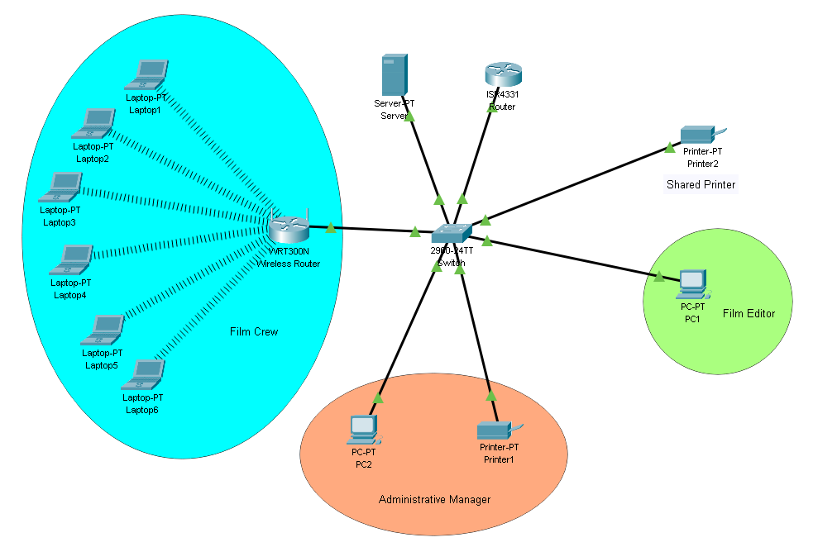

# **Security**

# To ensure the security of the network, the following measures will be taken in addition to the firewall appliance:

# Console and privileged modes will be secured with unique passwords.

# Passwords will be required to access email and FTP services.

# Telnet will be replaced with SSH, which is more secure and will also be password protected.

# All computer systems will have anti-virus, spyware protection, spam blockers, and other security measures installed.

# All passwords will be encrypted and unique from one another.

# HTTPS will be implemented.

# WPA2 personal encryption login details will be required for wireless connections to connect to the network.

# **Login Details**

|  |  |  |
| --- | --- | --- |
|  | **Username** | **Password** |
| **SSID** | AnyComp001 | S3cR3t980 |
| **E-mail account (Company)** | Company@AnyComp | SupR3m3c0mp |
| **E-mail account (Editor PC1)** | Frahan@AnyComp.com | Fr3d15c00l |
| **E-mail account (Admin PC2)** | Seema@AnyComp.com | 5U5an15g0d |
| **Priveleged EXEC Mode** | N/A | **g0dlic0mp0ni** |
| **User Mode** | N/A | **steyf0rAwey** |
| **SSH Network** | admin001 | **d0ng3r0saDm1n** |
| **FTP** | Companys | D0ntw0rY |

# **Contact Us**

We are open to making any necessary changes to the project to meet the specific needs of your company. We eagerly await your response and are available to answer any questions you may have. Please feel free to contact us via email at  [dispute your information online](http://www.experian.com/disputes/main.html) or by phone at (+1 888 397 3742).

Thanks,

*Experian IT Solutions*